PHASE 1 PROJECT

CODING

<br>

<br>

<html>

<head>

<body background="login.jpg" background-size=1000px><center>

<h1> <font color=white><b>LOGIN FORM</b></font></h1>

<br>

<form>

<p style="color:white;font-family:arial;font-size:19px;"> UserName</p>

<input type="text" name="login" size=20>

<p style="color:white;font-family:arial;font-size:19px;">Password</p>

<input type="password" name="password" size=20>

<br>

<br>

<br>

<input type="button" style="background-color:white ;color:black;width:100px;height:25px;"value="Submit">

</form>

</body>

</html>

OUTPUT

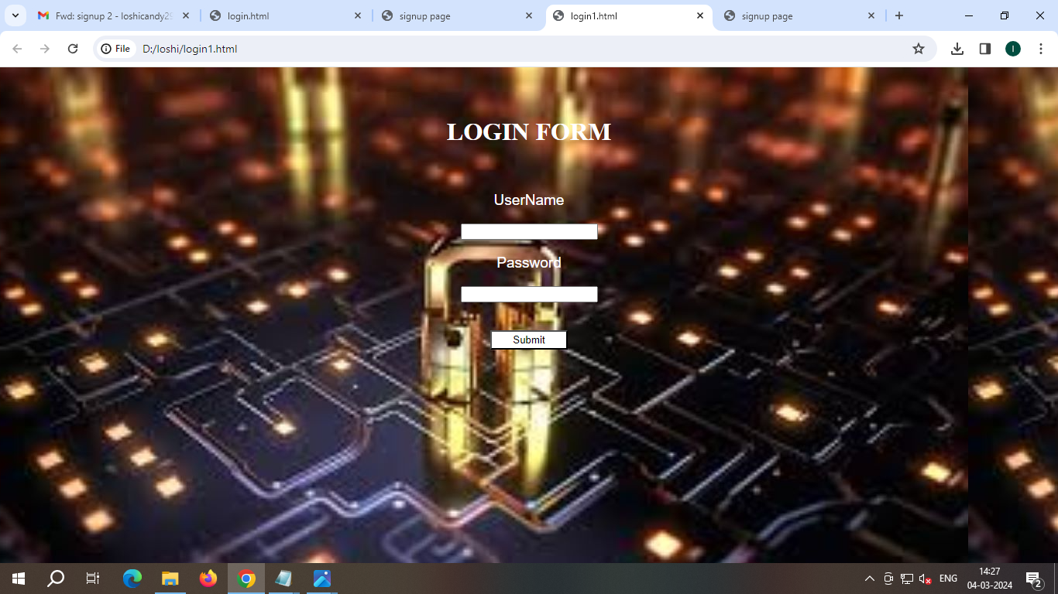

<br>

<br>

<html>

<head>

<title> signup page</title>

</head>

<body background="signup.jpg"><center>

<p style="color:#FFFFFF;font-size:40px;font-family:Latin;">SIGNUP FORM</p>

<p style="color:#FFFFFF;"> Please fill this form to create an account</p>

<br>

<form><font color=#FFFFFF>

<b>Name:</b>

<input type="text" placeholder="First Name\*" name="username" size=20 >

<input type="text" placeholder="Last Name\*" name="username" size=20 >

<br>

<br>

<b>Email:</b>

<input type="text" placeholder="Enter email" name="email" size=20>

<br>

<br>

<b>New Password:</b>

<input type="password" placeholder=" Creat Password" name="password" size=20>

<br>

<br>

<b>Confirm Password:</b>

<input type="password" placeholder="Confirm Password" name="password" size=20>

<br></font>

<br><font color=#FFFFFF>

<input type="checkbox" name="me" value="me" UNCHECKED><b>I accept all terms & conditions</b>

<br>

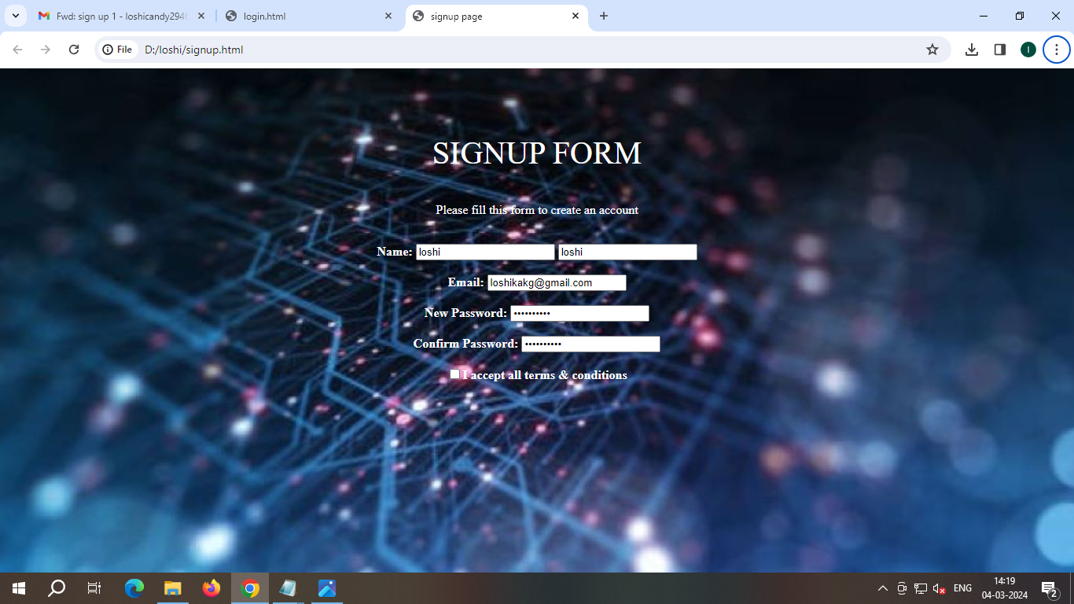

<br>

<br>

<html>

<head>

<body background="login1.jpg" background-size=1000px><center>

<h1> <font color=white>LOGIN FORM</font></h1>

<br>

<form>

<p style="color:white;font-family:arial;font-size:19px;"> UserName</p>

<input type="text" name="login" size=20>

<p style="color:white;font-family:arial;font-size:19px;">Password</p>

<input type="password" name="password" size=20>

<br>

<br>

<br>

<input type="button" style="background-color:white ;color:blacks;width:100px;height:25px;"value="Submit">

</form>

</body>

</html>

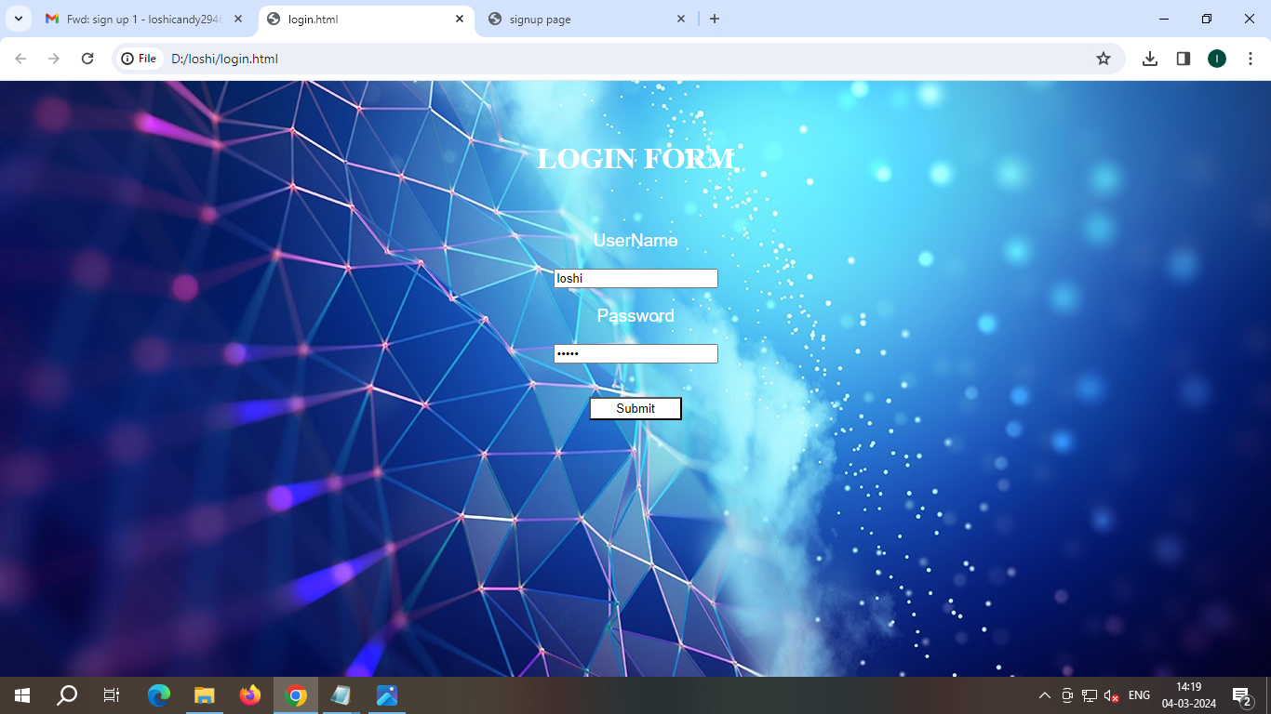

< html>

<head>

<title> signup page</title>

</head>

<body background="signup1.jpg"><center>

<p style="color:#FFFFFF;font-size:40px;font-family:Latin;">SIGNUP FORM</p>

<p style="color:#FFFFFF;"> Please fill this form to create an account</p>

<br>

<form><font color=#FFFFFF>

<b>Name:</b>

<input type="text" placeholder="First Name\*" name="username" size=20 >

<input type="text" placeholder="Last Name\*" name="username" size=20 >

<br>

<br>

<b>Email:</b>

<input type="text" placeholder="Enter email" name="email" size=20>

<br>

<br>

<b>New Password:</b>

<input type="password" placeholder=" Creat Password" name="password" size=20>

<br>

<br>

<b>Confirm Password:</b>

<input type="password" placeholder="Confirm Password" name="password" size=20>

<br></font>

<br><font color=#FFFFFF>

<input type="checkbox" name="me" value="me" UNCHECKED><b>I accept all terms & conditions</b>

<br>

<br></font>

<button type="submit" class="signupbtn">SignUp</button>

<button type="button" class="cancelbtn">Cancel</button></center>

</form>

</body>

</html>

